Optitrack Integration with SPA sites

The Integration of Optitrack with SPA sites should include the following actions:

* Update the tracking data in the loaded site (initialize the Optitrack i.e. Site Id, Tracking URL, Page View, UserId if exist) using the script obtained from optimove.
* Update UserId when customer logins and the PublicUserId is available.
* Update the current page URL when routing to a page (a view).

**There are two options to implement this:**

1. Integrate Optitrack by embedding JS Code in the Site.
2. Integrate Optitrack by GTM.

# Embedding JS Code in the Site (less preferable)

* Embedding of JavaScript code (using <script> Tag), this tag should be executed in the load of the page (SPA layout).
* When route occurs call JS code:

_*paq.push(['trackPageView', <page URL>]);*

* When PublicCustomId is available (user sign-in) call JS code:

*_paq.push([setUserId, <PublicCustomerId>]);*

### Optitrack Initializing Script Tag -Embedded Version:

Copy and paste the JavaScript tracking code into your pages, just after the opening **<body>**

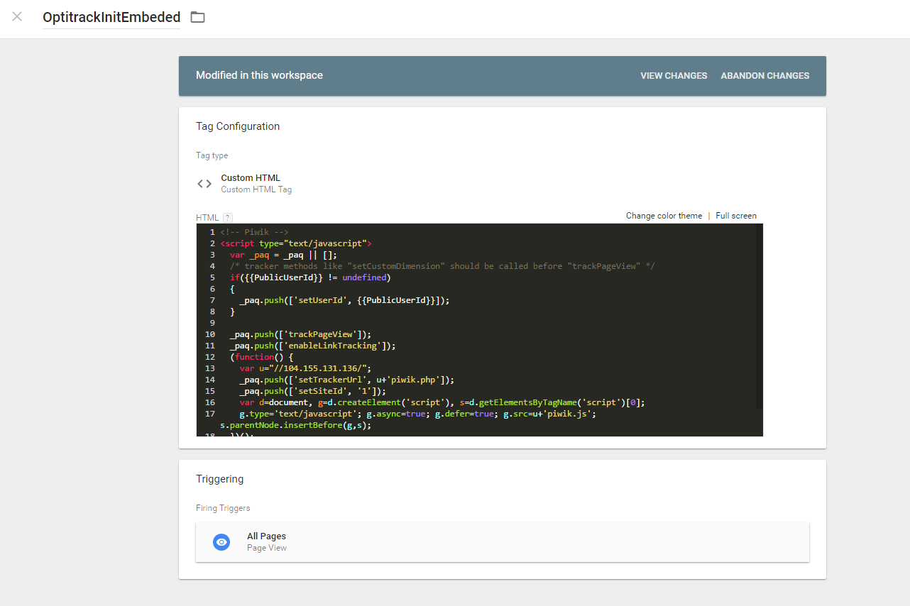

# Using GTM (preferable)

**Using the GTM would mean adding Tags, Variables and Triggers to your GTM Container.**

## In the implementation example, we use the following:

* 3 GTM **Custom HTML** Tags.
* 2 GTM **JavaScript/DataLayer** Variables.
* 2 GTM **Triggers**.

## GTM objects that are needed for the SPA interaction with the OptiTrack.

### GTM **Custom Triggers**

We should create 2 Triggers which will trigger the Tags (defined in the following steps)

* **URLChangeEvent –** event of changing of the SPA page.
* **UserIdUpdateEvent –** event of public user id update.

### GTM **DataLayer Variables**

Create 2 DataLayer Variables which will be used by the GTM Tags

* **CurrentPageURL –** DataLayer variables which supplies the new page URL.
* **PublicUserId -** DataLayer variables which supplies the public user ID.

### GTM **Custom HTML Tags**

* **OptitrackInit** Tag GTM Custom HTML Tag which includes our base Optitrack JavaScript code.

And would initialize the Optitrack for the site.

**Fired On**: Tag should be fired when Page was loaded GTM Trigger **Once Per Page**.

* **PageChange** **Tag** - GTM Custom HTML Tag which includes the code:

_*paq.push(['trackPageView', {{* **CurrentPageURL***}}]);*

Using this event, we will be able to update the Optitrack with the current site URL.

**Fired On**: Tag should be fired when Page Routing was initiated on event URLChangeEvent.

* **UserIdUpdate** **Tag** - GTM Custom HTML Tag which includes the code:

_*paq.push([ ‘setUserId’, {{* **PublicUserId** *}} ]);*

**Fired On**: Tag should be fired when **publicUserId**(usually after user sign-In) is available on event UserIdUpdateEvent.

## Following are the Tags, Variables and Triggers examples in GTM

### Optitrack Initializing Script Tag -Embedded Version:

***<****script type****=****"text/javascript"****>***

*var _paq* ***=*** *_paq* ***|| [];***

*if****(****CustomerID_Is_Known****){*** *_paq.push(['setUserId',* *{{PublicUserId}}]);*

***}***

*_paq.push(['trackPageView']);*

*_paq.push(['enableLinkTracking']);*

*(function() {*

*var _siteId* ***=*** *your_site_ID****;***

*var u****=((****"https:"* ***==*** *document****.****location****.****protocol****) ?*** *"https"* ***:*** *"http"****) +*** *"://your_site_subdomain.optimove.net/"****;***

*_paq****.****push****([****'setTrackerUrl'****,*** *u****+****'piwik.php'****]);***

*_paq****.****push****([****'setSiteId'****,*** *_siteId****]);***

*var d=document, g=d.createElement('script'), s=d.getElementsByTagName('script')[0]; g.type='text/javascript';*

*g.defer=true; g.async=true; g.src=u+'piwik.js'; s.parentNode.insertBefore(g,s);*

*})();*

***</****script****>***

## Optitrack Initializing Script Tag

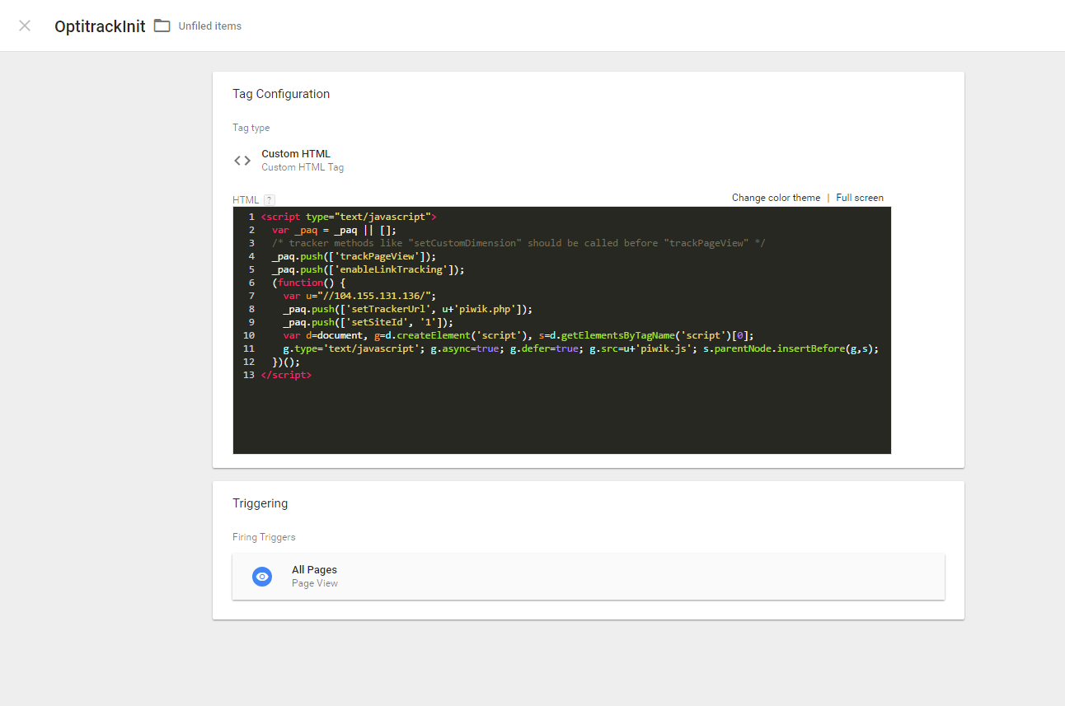

## Optitrack PageChange Tag

**Note**: do not use the IP Address given in the Tag example.

## Optitrack PageChange Tag

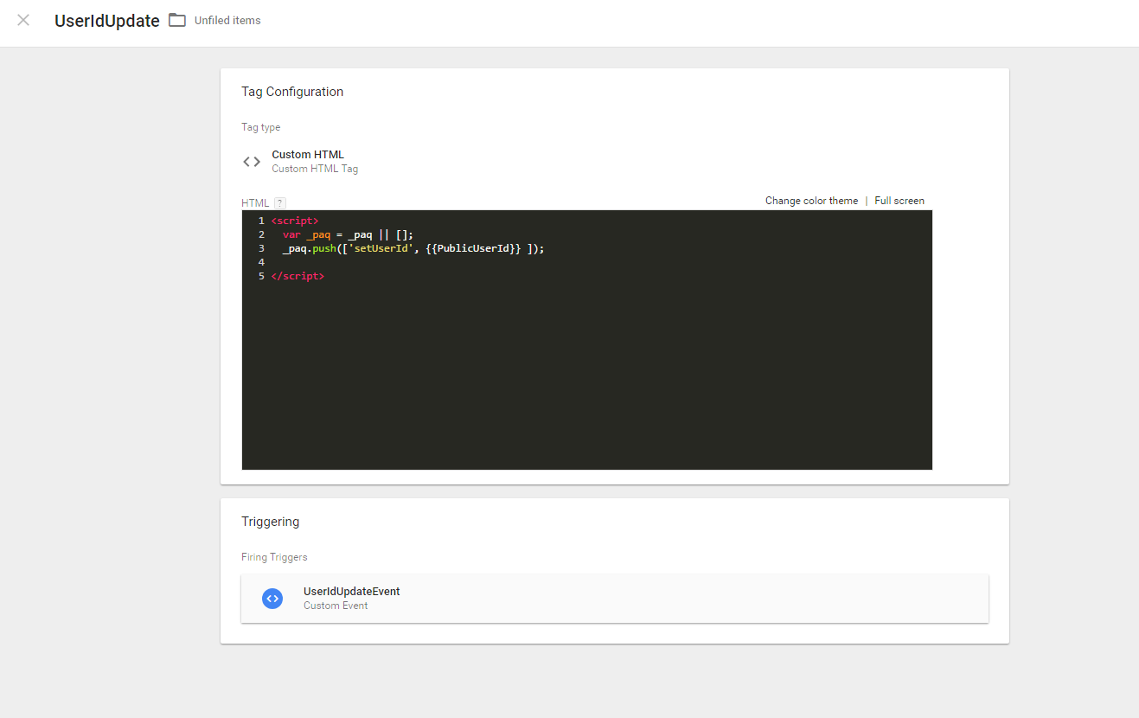

## Optitrack Triggers

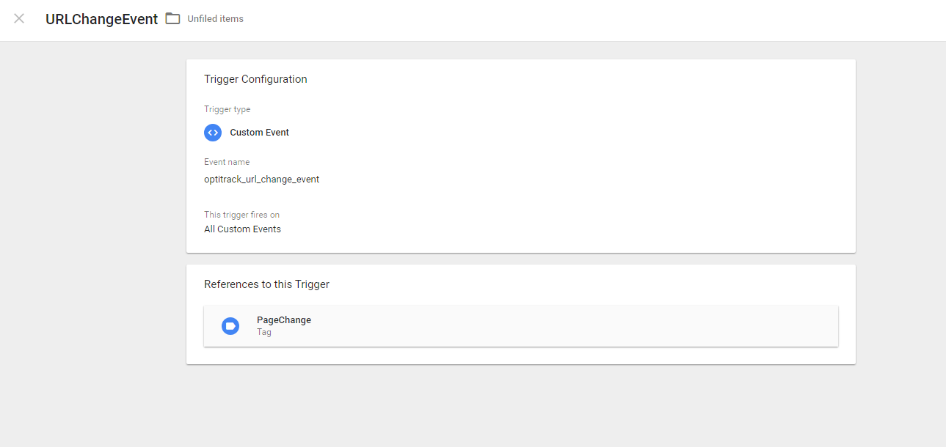

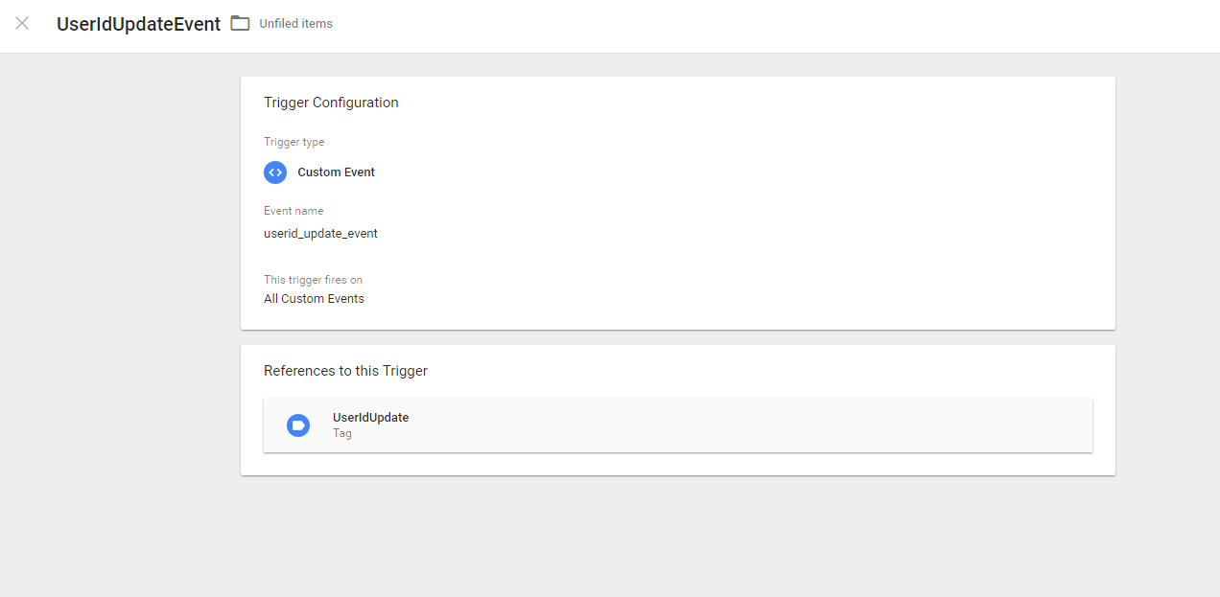

## Optitrack DataLayer Variables

